Why Students in Kentucky Have Been Praying for 250 Hours
‘You need to come back to chapel, something is happening.’ On the ground at the Asbury Revival.
By Olivia Reingold
February 19, 2023

https://www.thefp.com/p/why-students-in-kentucky-have-been

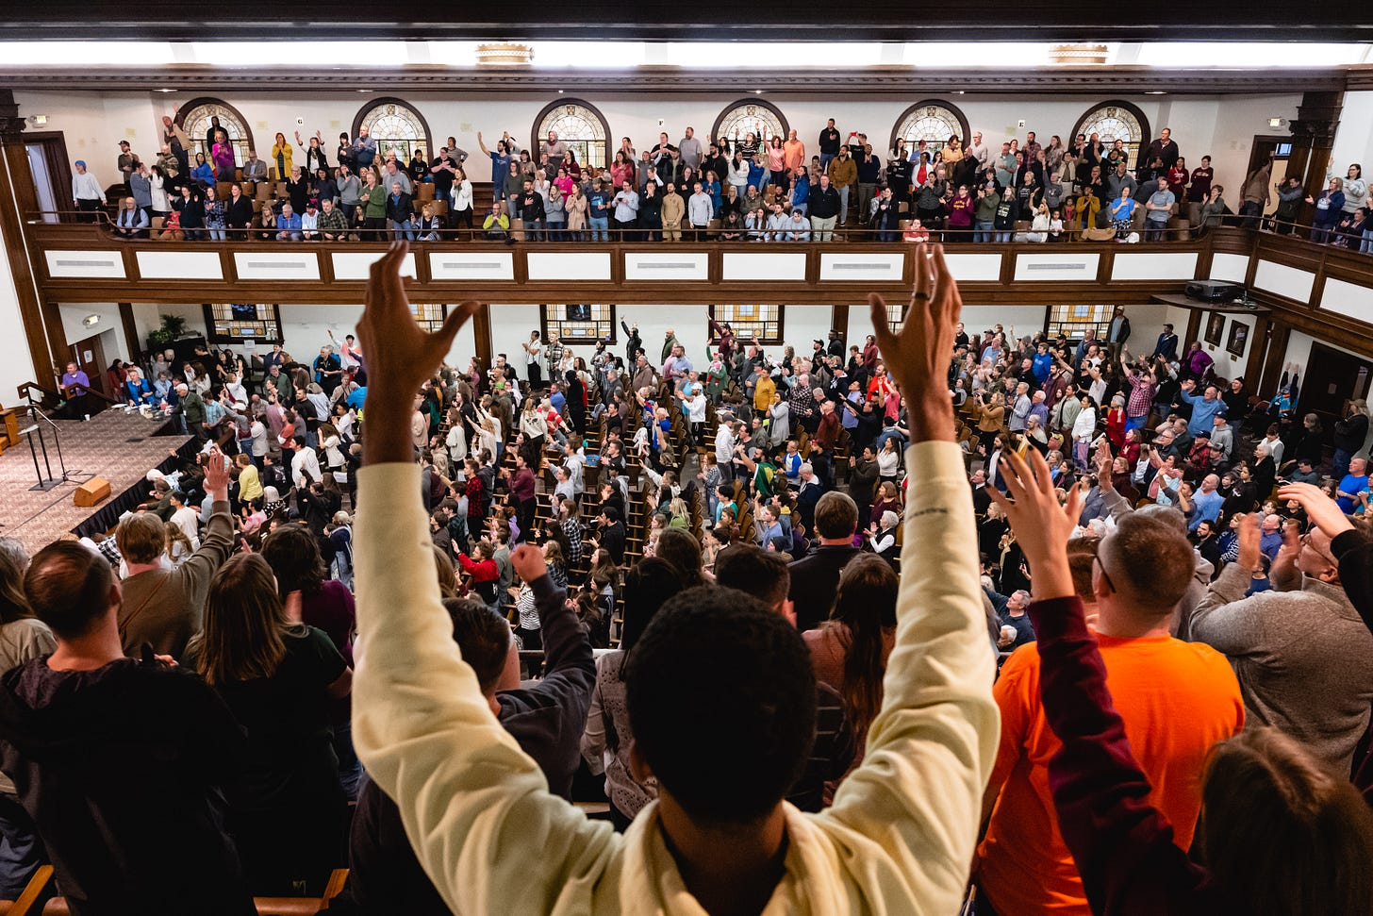
All photos by Jon Cherry for The Free Press.
For the last four years at her Christian college, Gracie Turner had been keeping a secret.
She had lost her faith.
In high school, she watched cancer ravage her great-grandmother. Then she saw her family fall apart. One fight drove her to call the police on a relative.
“I just remember thinking, why is this happening? How could this happen? And my first thought, or first person to blame was God,” Turner, a 21-year-old film major, told me. “I would lay in bed sometimes and just pray to God, like, it would be really nice if I didn’t wake up tomorrow.”
When she got to Asbury University in Wilmore, Kentucky, she was required to go to chapel three times a week for college credit. But she never believed God would fix anything, since life only seemed to be getting harder between the anxiety, depression, and recent back injury that brought her to a “breaking point.”
But last Sunday, something changed. She woke up and spontaneously blurted an idea to her roommate: What if, instead of doing homework, we went to chapel today?

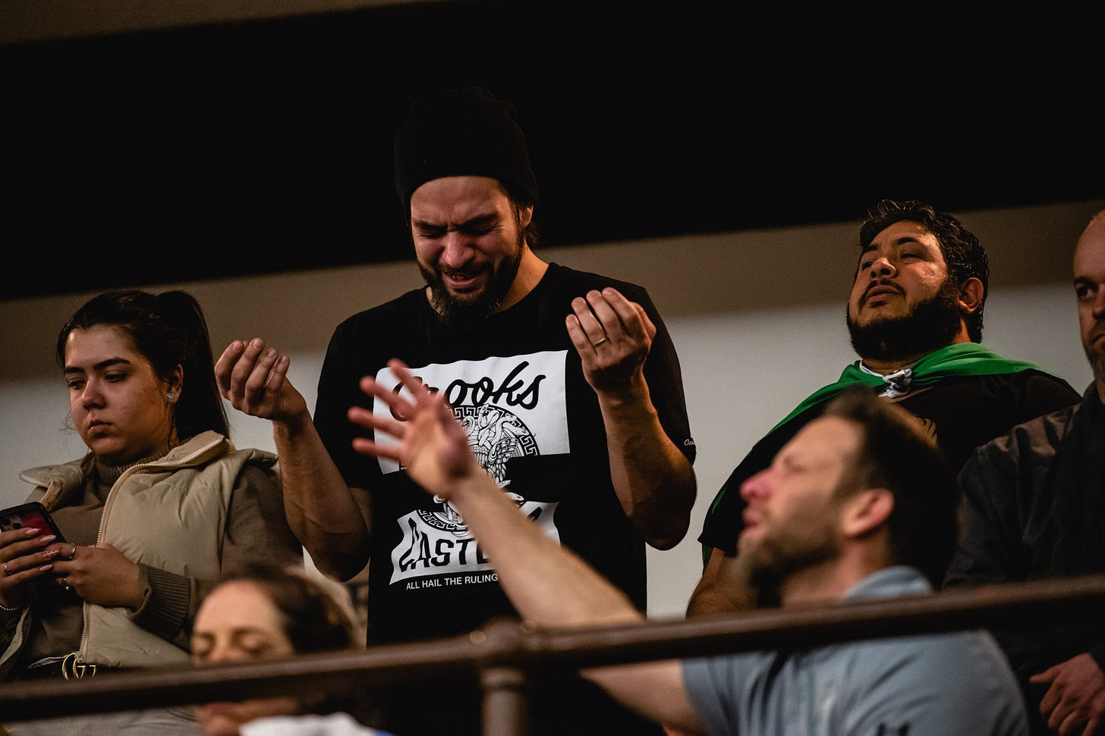

She had heard a revival had sprung forth a few days earlier there, and hadn’t stopped. When she opened the doors, the same chapel that had never spoken to her before suddenly seemed alive. The pews were packed with more than a thousand people—including many of her classmates—weeping and swaying with their eyes closed to nothing but an acoustic guitar and each other’s voices.
Suddenly, Gracie Turner no longer felt any pain.
“I just slumped down,” she told me. “It was the first time in a long time where I could finally just rest because I felt like I was at peace, and I was protected. I felt like it was God telling me, this is what you’ve been missing.”

For the past two weeks, tens of thousands of visitors have poured into that Kentucky chapel to experience what Turner felt that day. (On Saturday alone, according to a university spokesperson, the crowd numbered between 15,000 and 20,000.) Some are driving overnight from states like South Carolina and Oklahoma. Others are flying in from Canada and Singapore to wait in line for hours—sometimes in the rain or snow—just to stand next to people they share nothing in common with except for a single conviction: God is visiting a two-stoplight town in Kentucky.
Inside sounds like a concert, but feels more like a campfire. Voices rise and fall in unison to soft guitar and piano music, and everyone knows the words: “Holy Spirit, come rest on us. You’re the only one.” In between the songs and prepared sermons, pastors hand the mics over to teenagers, who flood the altar to share stories of broken hearts and anxiety. The crowd claps at every tale of being saved—from torn ligaments, drug addictions, crises of faith.
Listen here:
It all started on Wednesday, February 8, when Zach Meerkreebs, a volunteer soccer coach who had addressed the student body only twice before, gave an improvised sermon about love.
“Some of you guys have experienced radically poor love,” Meerkreebs, a tattooed 32-year-old with a penchant for kombucha, told the crowd. “Some of you guys have experienced that love in the church. Maybe it’s not violent, maybe it’s not molestation, it’s not taken advantage of—but it feels like someone has pulled a fast one on you.”
Then he uttered the invitation that ignited a movement: “If you need to hear the voice of God—the Father in Heaven who will never love you that way, that is perfect in love, gentle and kind—you come up here and experience his love. Don’t waste this opportunity.”
In a final, kind of corny throwaway line, he said: “I pray that this sits on you guys like an itchy sweater, and you gotta itch, you gotta take care of it.”
Meerkreebs told me he was certain that he had “totally whiffed” the sermon, and immediately got off stage and texted his wife, “Latest stinker. I’ll be home soon.”
But students, moved by his message, lingered.

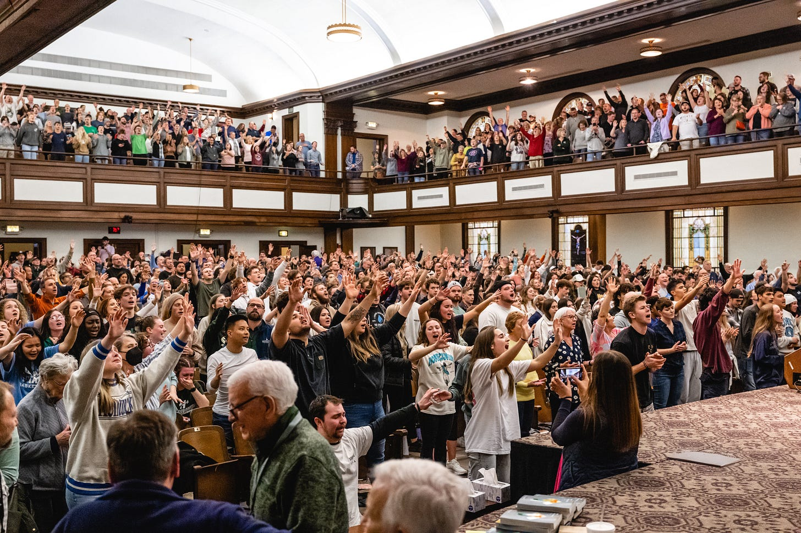

At first, he said it was just eighteen of them who stayed back to pray while everyone else headed to class. But then students began texting each other: you need to come back to chapel, something is happening.
Every day, more students came, praying and singing around the clock, taking shifts between classes and mealtimes and even at bedtime to the point the chapel never emptied. Soon, reports of similar around-the-clock prayer sessions were popping up at other college campuses, including Lee University in Tennessee, Cedarville University in Ohio, and Samford University in Alabama.
Some Asbury students told me they grew up praying for a revival—meaning a resurgence of faith that spreads, usually at a community level but occasionally throughout the entire nation. Those students believe that dream is now becoming reality among the generation marked by its lack of faith in anything.
Gen Z is the most likely generation yet to say they don’t believe in God. They are also the least religiously affiliated and the least likely to attend church.
Meantime, their rates of depression and anxiety are soaring. The Centers for Disease Control recently published a report stating that “almost 60% of female students experienced persistent feelings of sadness or hopelessness during the past year and nearly 25% made a suicide plan.”

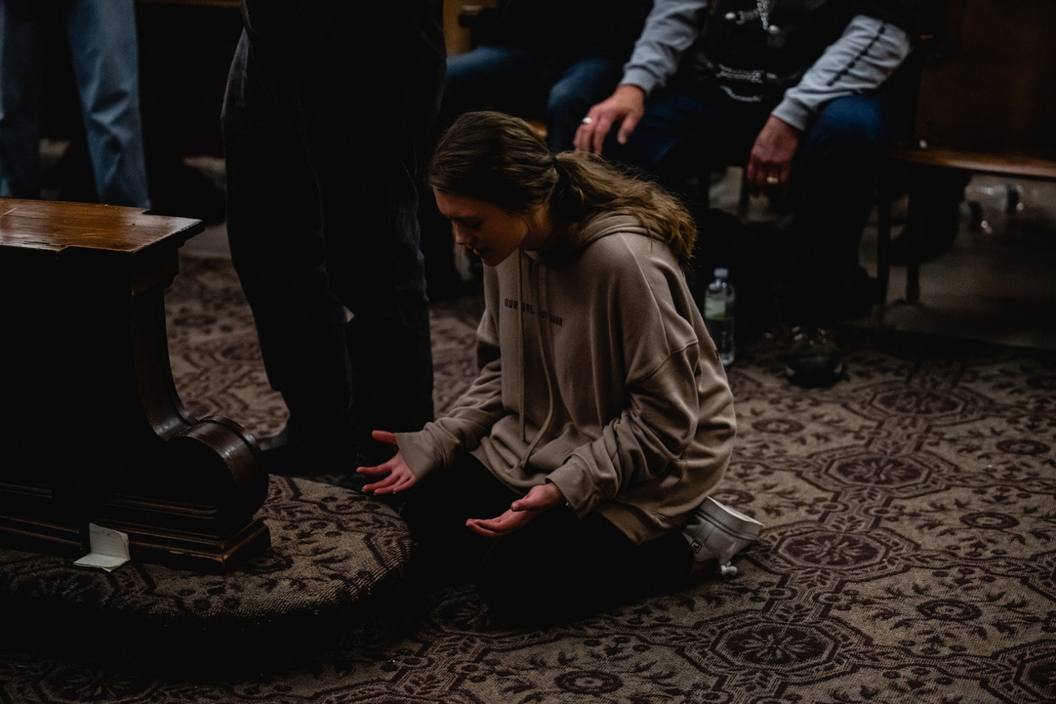

Social media has amplified much of this young generation’s ennui. But over the last few days, it has also been used to promote the religious revival at Asbury, where reports first hit TikTok, then Twitter, then Facebook, and eventually Tucker Carlson on Fox News, who called the scenes “remarkable.” Though Asbury recently started to contain the revival overnight, it hasn’t stemmed the tide.
Lydia Nowak, 20, says it’s true what they say about her generation. She said she’s hardly met any believers her age, and she journeyed to Asbury from North Carolina, where she is a junior at Appalachian State University, to find people like her.
“I have hardly seen any other people who just actually love Jesus and worship and pray,” Nowak says. Then about Asbury: “This is huge to see.”

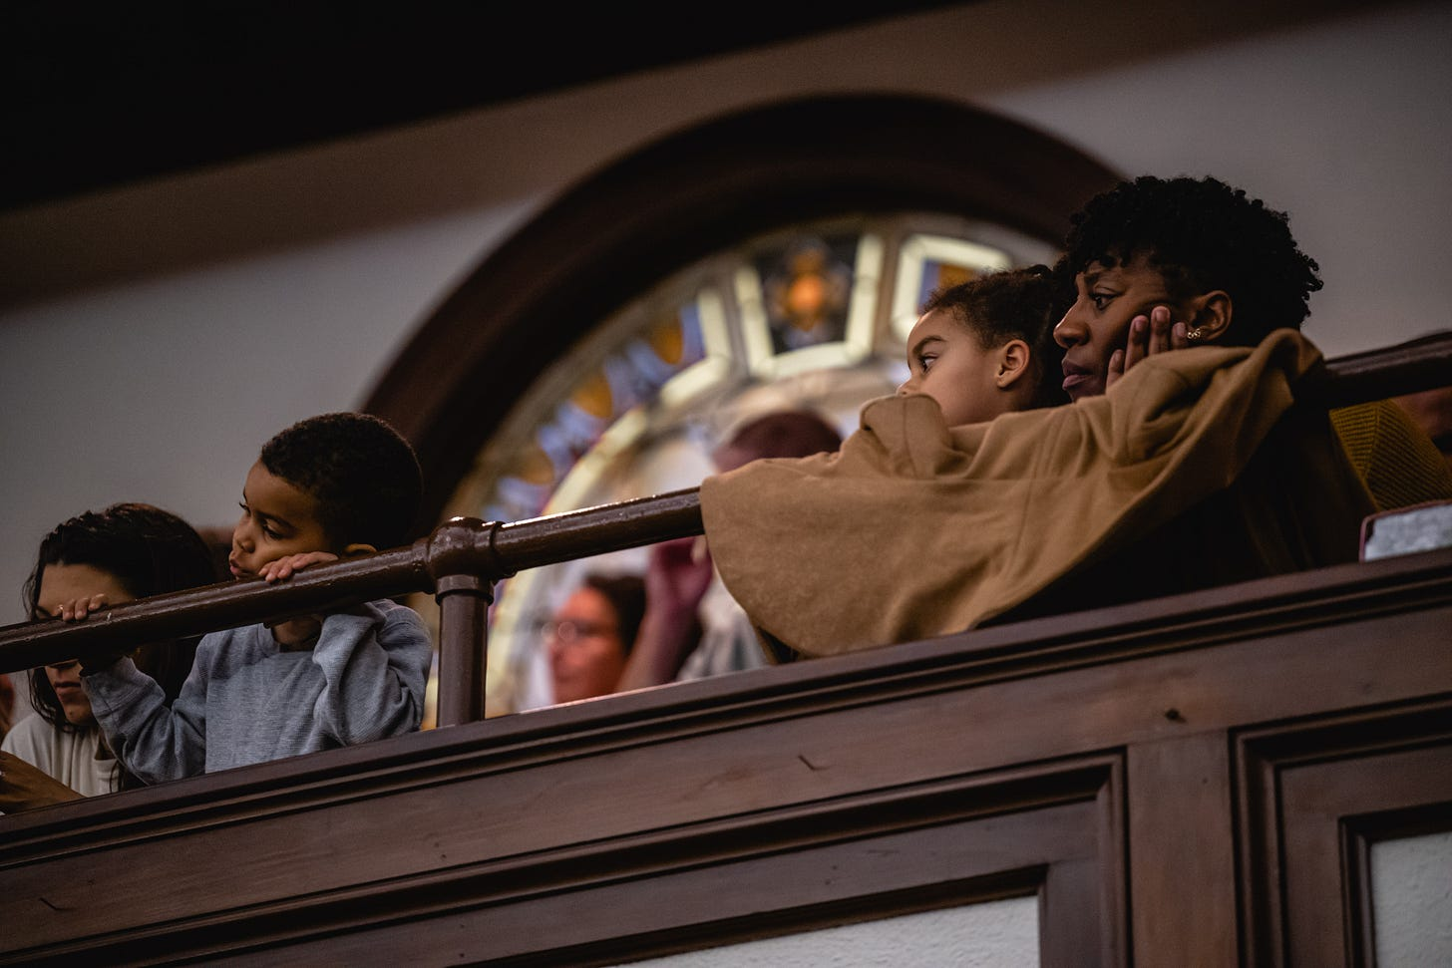

This is not the first time Wilmore has combusted with prayer—the university website lists eight prior revivals, with the largest cresting in 1970, when other college campuses were erupting with anti-war fervor and violent clashes with police.
Revivals were at their height in eighteenth-century America, when evangelist preachers cast aside stuffy ceremonies to spread the Holy Spirit among crowds in fields or city streets. In more modern times, colleges, like Wheaton in Illinois in 1950—rather than churches—have been the center of revivals.
Leonard Fitch attended the 1970 revival at Asbury, and says he’s been praying for another big one here ever since.
“I have a granddaughter who graduated from Asbury. And her brother went to a secular school in Virginia,” says Fitch, 82, an Asbury graduate and local grocery store owner. “She’s had a wonderful life . . . and he took his life. And that, to me, says it all.”
At 18, Ava Miller, an Asbury freshman, has also been praying for a revival, knowing how much her friends are struggling with their mental health.
“I can see and feel the heaviness of the people around me,” says Miller, who grew up in Wilmore. “You just feel that heaviness. As a believer, I’ve gotten to experience the freedom of getting to live in that hope, and I think hope is something that extinguishes that fire of darkness.”

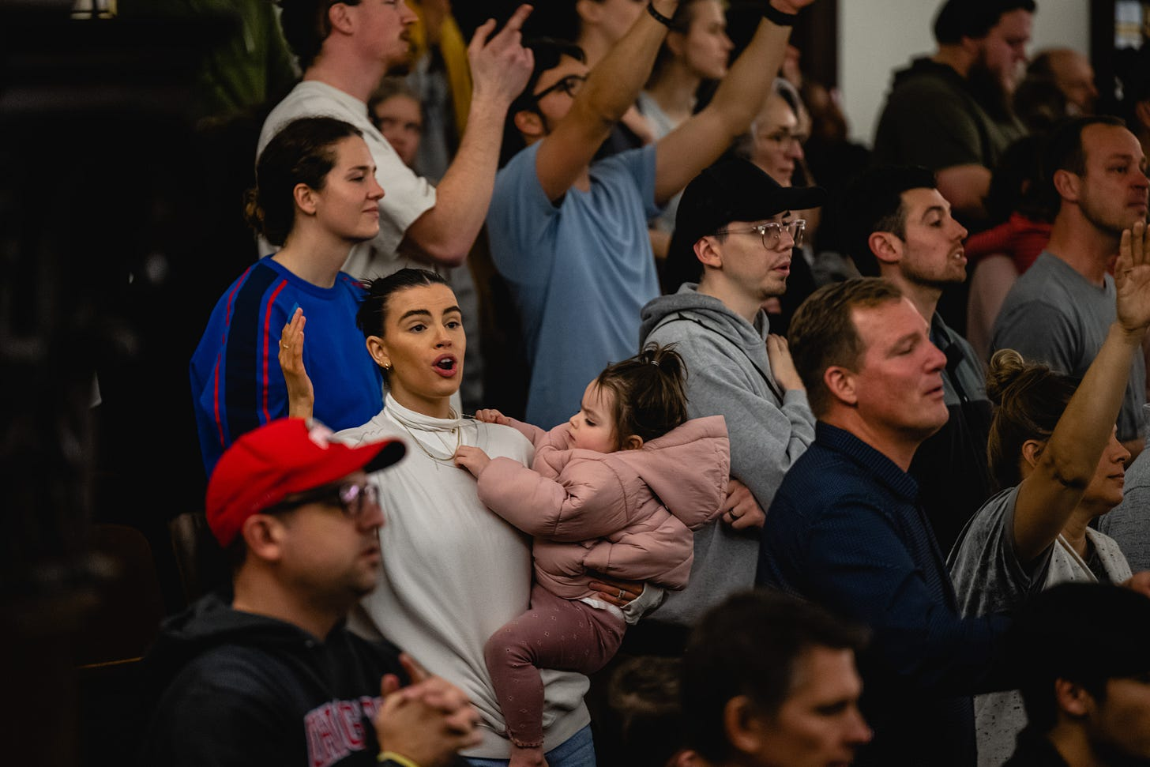

The past few years have felt extra dark, after two years of Covid disruptions and a life moved online even more than usual.
“There’s just a lack of hope that seems to have been struck up with the younger generations,” says Carter Hammond, a 23-year-old Asbury student, about the impact of Covid. “It just creates this environment that seems kind of desolate.”
Hammond says he’s used to seeing his peers pull out their phones at mandatory chapel services. “​And to see the total opposite of that happening is really, really cool.”

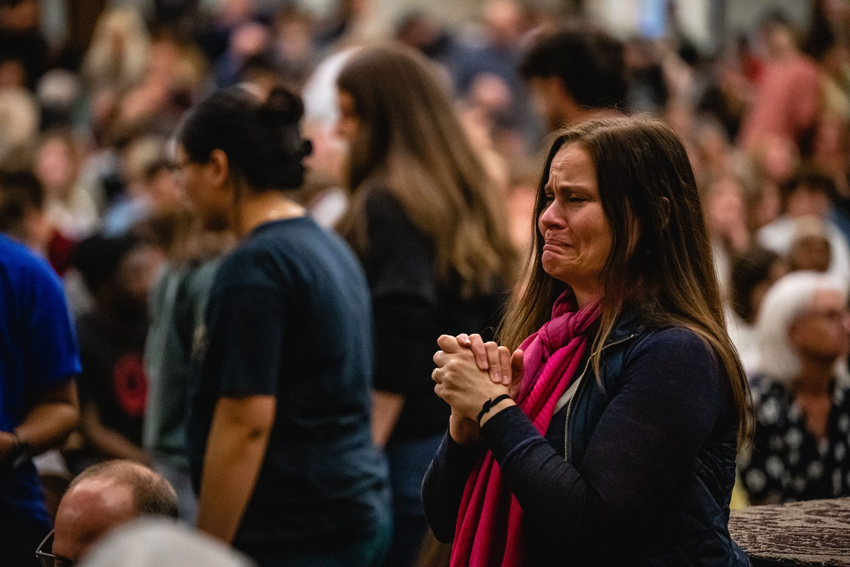

Back in the chapel, students and now visitors—dudes in cowboy boots and muddy jeans, a man in the back with an oxygen tank, a woman breastfeeding under a scarf—seem to be discovering a new connection, which is actually a very old one that previous generations felt more easily in the absence of today’s technology.
“We’re seeing a great awakening of 18- to 25-year-olds,” says Garrett English, who drove all the way from Clemson University in South Carolina to witness the scenes for himself. “This right here—this is amazing. We are seeing college-age students fighting for other college students’ faith.”
Clyde Vanworth, 68, is outside in the moonlight, journaling about the young people inside who now carry the torch he’s worked hard to protect. Last year, Vanworth gave up his post as a missionary in Vietnam after a decade there. Now he’s a volunteer usher at the Asbury chapel. He sips coffee from a styrofoam cup before starting another shift.
“We really need to be blessing these people and holding the door open for them,” says Vanworth about the youth movement.
When I notice he’s holding back tears, I ask him why. “Seeing this next generation come to life does my heart good.”

Olivia Reingold covers politics and culture for The Free Press. Read her recent story about America’s love affair with Ozempic here.

